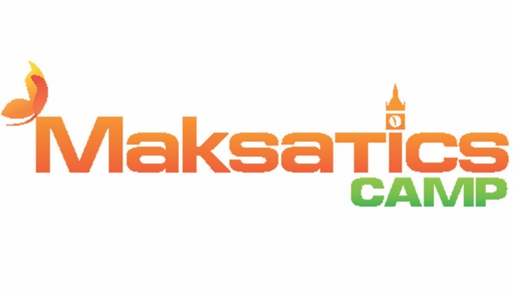
TRAVEL PACKING LIST

Important: the number of items should correspond to the duration of the trip.
We recommend bringing a set of t-shirts, socks, and underwear for each day of the term.

This time of the year is always hot, so number of swimsuits, shorts and t-shirts should be enough.
For evening and concert once we recommend to take 3-4 outfits for girls, and 4-3 shirts with short sleeves for boys.
A cap!
Trainers for sport and hiking.
All things must be signed/marked with coloured ribbons. For example, you can use personal stickers for clothes.

Hygiene items:

Toothpaste and brush, comb, sufficient number of scrunchies/hair clips (for girls).
Individual signed water bottle.
For young men - razor, shaving foam, after-shave cream; for young ladies - intimate hygiene products.
Deodorant with weak natural aroma (Not aerosol!) if needed. Please, do not take perfume in a glass bottle!
Sunscreen and moisturising nourishing cream with necessary degree of protection.
15 face masks.

Other:

Suitcase/luggage (please, include a note with the child's full name, parents’ phone numbers, and home address if you are unsure that your child remembers his/her personal information).
A small bag or light backpack for essential things on excursions and trips.
On request you can also take a small musical instrument on which the child plays (guitar, flute, harmonica, etc.)
Something for masquerade, like a favourite hero costume, a wig, or some kind of fancy accessorises.

Pocket money:

You can give money for souvenirs in a signed wallet to your child or to team leader for safekeeping. You need to write the child's full name and the amount of money on the wallet. When travelling on excursions, children will be allowed to bring their purses with them, reducing the likelihood that they may lose money. It is recommended to give no more than €100 pocket money, although the amount is not limited.

It is not recommended to take: jewellery and expensive equipment like mobile phones, cameras, or players since there is a high risk that the child will lose them. To prevent such problems, you may, for example, give your child the low-cost mobile phone model to communicate with you. The organisers are not liable for any loss, damage, or disappearance of such items.
It is strictly forbidden to bring in: drugs, including snus and energy drinks - all alcoholic beverages (including low alcoholic), tobacco, any pyrotechnics (firecrackers, crackers, etc.), knives, slingshots, and other weapons.

Important:

Please, explain to your child that if someone is found in possession of the above items, for violating the rules of residence and the applicable legislation (theft, immoral behaviour, arbitrary actions that can harm his/her or others’ health, smoking, drinking alcohol or using drugs, etc.), the child may be expelled from the camp early without a refund or the trip cost and taking home at the expense of the parents. If the child is found to be in possession of drugs, the case will be referred to the police. Property damage is entirely the responsibility of the child’s parents. The arrival of a child is interpreted as the child’s and his parents’ agreement to follow the rules. Everyone must comprehend that they are going to the collective of children.

